**SITTA CC CORONA 2.7.20**

**Surgical Masks, Respirators, Barrier Masks: Which Masks Actually Protect Against Coronavirus?**

**Info from emag.medicalexpo.com   by Celia Sampol.**

**This is dated 28.2. !! Conclusion: Only respirators help, normal masks not ( and putting a shawl or any textile before your face is utter nonsense! What the government thinks it is doing? ). So if you believe you are endangered you have to get an respirator.**

Since the outbreak, people in China and in the rest of the world have rushed to their local pharmacies to get surgical masks. But there are different types of masks on the market, and not all of them are really effective against this virus. So, which masks actually offer protection?

**Surgical Masks vs. Respirators**

There are two different types of masks: surgical masks and respirators.

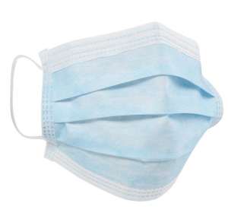

Surgical mask (Credit: DACH Schutzbekleidung)

***>>>******A surgical mask****is a disposable medical device that can be bought in pharmacy and that protects against infectious agents transmitted by “droplets.” These droplets can be droplets of saliva or secretions from the upper respiratory tract when the wearer exhales.*

If worn by the caregiver, the surgical mask protects the patient and his or her environment (air, surfaces, equipment, surgical site). If worn by a contagious patient, it prevents the patient from contaminating his or her surroundings and environment. These masks should not be worn for more than 3 to 8 hours, depending on use.

A surgical mask can also protect the wearer from the risk of splashes of biological fluids. In this case, the surgical mask must have a waterproof layer. It can also be equipped with a visor to protect the eyes.

***But a surgical mask does not protect against “airborne” infectious agents so it will not prevent the wearer from being potentially contaminated by a virus such as the Coronavirus.***

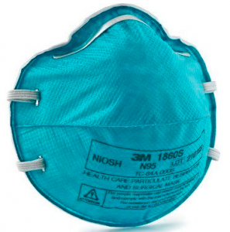

N95 respirator (Credit: 3M)

***>>>******A respirator is personal protective equipment that prevents the wearer from inhaling aerosols (dust, smoke, mist) as well as vapours or gases (disinfectants, anaesthetic gases) that are health hazards. Unavailable in pharmacy, it protects the wearer from airborne infectious agents i.e. against contamination by a virus such as coronavirus, SARS, H1N1, etc****.*

Respirators are divided into two categories: insulating and filtering. Filtering respirators consist of a facepiece and a filtering device. Sometimes the filter element is integrated into the facepiece. Depending on the type of filter, the mask will either be effective only against particles, only against certain gases and vapours, or against particles, gases and vapours.

Filtering respirators can sometimes also be equipped with an exhalation valve to improve user comfort. The valve prevents condensation inside the mask, misting on the glasses and helps the user breathe in and out easily.

It should be noted that respirators also protect those who wear them from inhaling “droplets” of infectious agents. Respirators can be disposable or reusable. In the second case, it is possible to replace the filter when it is full.